https://fsd.tcsbank.ru/case/4359347/info

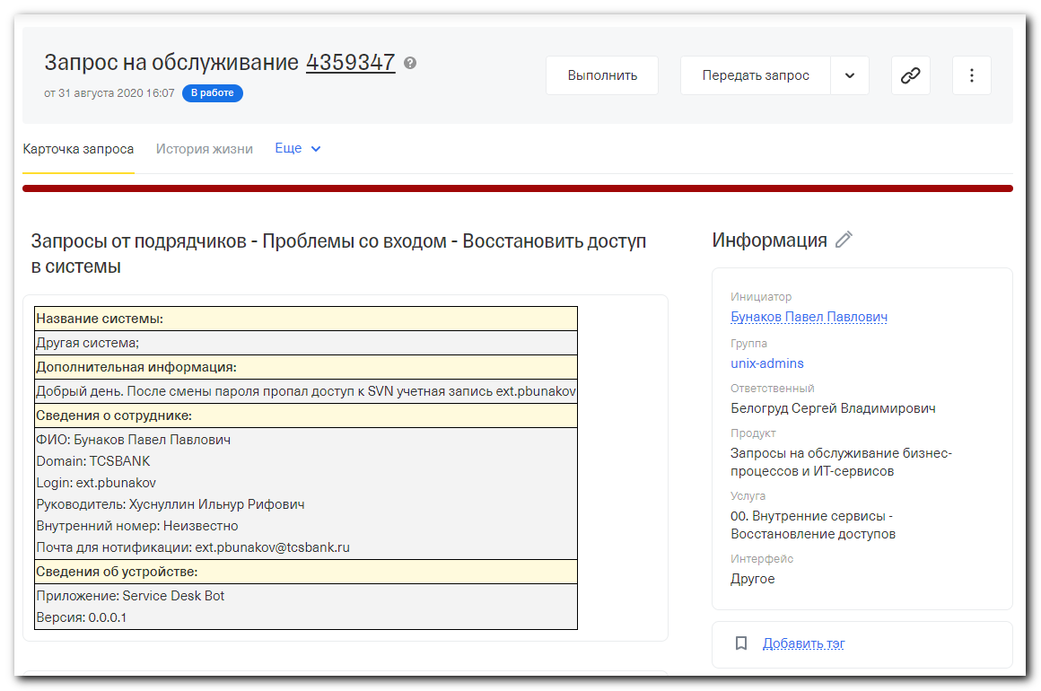
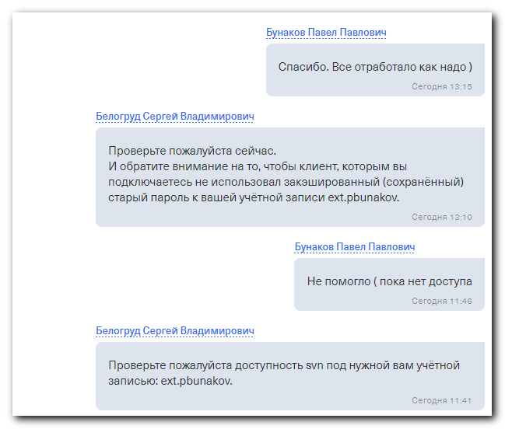

#
# To fix this issue, I restarted httpd server.
#
[root@devel ~]# service httpd restart
Stopping httpd: [ OK ]
Starting httpd: httpd: Could not reliably determine the server's fully qualified domain name, using devel.tcsbank.ru for ServerName
[ OK ]
[root@devel ~]# service httpd status
httpd (pid 31514 31513 31512 31511 31510 31509 31508 31507 31505) is running...
[root@devel ~]#

................................................................................
#
# No access.
#
[root@devel ~]# less /var/log/httpd/access_log | grep -ie "ext.pbunakov"
10.216.29.83 - ext.pbunakov [01/Sep/2020:07:46:08 +0300] "OPTIONS / HTTP/1.1" 401 481 "-" "SVN/1.9.7 (x64-microsoft-windows) serf/1.3.9 TortoiseSVN-1.9.7.27907"
10.216.29.83 - ext.pbunakov [01/Sep/2020:07:46:29 +0300] "OPTIONS / HTTP/1.1" 403 282 "-" "SVN/1.9.7 (x64-microsoft-windows) serf/1.3.9 TortoiseSVN-1.9.7.27907"
10.216.29.83 - ext.pbunakov [01/Sep/2020:07:46:29 +0300] "OPTIONS / HTTP/1.1" 401 481 "-" "SVN/1.9.7 (x64-microsoft-windows) serf/1.3.9 TortoiseSVN-1.9.7.27907"
10.216.29.83 - ext.pbunakov [01/Sep/2020:07:46:29 +0300] "OPTIONS / HTTP/1.1" 403 282 "-" "SVN/1.9.7 (x64-microsoft-windows) serf/1.3.9 TortoiseSVN-1.9.7.27907"
10.216.29.83 - ext.pbunakov [01/Sep/2020:07:46:29 +0300] "OPTIONS / HTTP/1.1" 403 282 "-" "SVN/1.9.7 (x64-microsoft-windows) serf/1.3.9 TortoiseSVN-1.9.7.27907"
10.216.29.83 - ext.pbunakov [01/Sep/2020:11:45:27 +0300] "OPTIONS / HTTP/1.1" 401 481 "-" "SVN/1.9.7 (x64-microsoft-windows) serf/1.3.9 TortoiseSVN-1.9.7.27907"
10.216.29.83 - ext.pbunakov [01/Sep/2020:11:45:53 +0300] "OPTIONS / HTTP/1.1" 403 282 "-" "SVN/1.9.7 (x64-microsoft-windows) serf/1.3.9 TortoiseSVN-1.9.7.27907"
10.216.29.83 - ext.pbunakov [01/Sep/2020:11:45:54 +0300] "OPTIONS / HTTP/1.1" 401 481 "-" "SVN/1.9.7 (x64-microsoft-windows) serf/1.3.9 TortoiseSVN-1.9.7.27907"
10.216.29.83 - ext.pbunakov [01/Sep/2020:11:45:54 +0300] "OPTIONS / HTTP/1.1" 403 282 "-" "SVN/1.9.7 (x64-microsoft-windows) serf/1.3.9 TortoiseSVN-1.9.7.27907"
10.216.29.83 - ext.pbunakov [01/Sep/2020:11:45:54 +0300] "OPTIONS / HTTP/1.1" 403 282 "-" "SVN/1.9.7 (x64-microsoft-windows) serf/1.3.9 TortoiseSVN-1.9.7.27907"
[root@devel ~]#

................................................................................
#
# Here, for example, access exists.
#
[root@devel ~]# zgrep -ie "ext.pbunakov" /var/log/httpd/access_log.4.gz | tail
10.216.24.76 - ext.pbunakov [28/Aug/2020:16:06:59 +0300] "PROPFIND /dwhmodel/Project/ReleaseManagement/DW-28249 HTTP/1.1" 207 744 "-" "SVN/1.7.14 neon/0.30.0"
10.216.24.76 - ext.pbunakov [28/Aug/2020:16:06:59 +0300] "OPTIONS /dwhmodel/Project/ReleaseManagement/DW-28249 HTTP/1.1" 200 188 "-" "SVN/1.7.14 neon/0.30.0"
10.216.24.76 - ext.pbunakov [28/Aug/2020:16:06:59 +0300] "PROPFIND /dwhmodel/Project/ReleaseManagement/DW-28249 HTTP/1.1" 207 744 "-" "SVN/1.7.14 neon/0.30.0"
10.216.24.76 - ext.pbunakov [28/Aug/2020:16:06:59 +0300] "PROPFIND /dwhmodel/!svn/vcc/default HTTP/1.1" 207 403 "-" "SVN/1.7.14 neon/0.30.0"
10.216.24.76 - ext.pbunakov [28/Aug/2020:16:06:59 +0300] "PROPFIND /dwhmodel/!svn/bln/345049 HTTP/1.1" 207 464 "-" "SVN/1.7.14 neon/0.30.0"
10.216.24.76 - ext.pbunakov [28/Aug/2020:16:06:59 +0300] "REPORT /dwhmodel/Project/ReleaseManagement/DW-28249 HTTP/1.1" 200 112 "-" "SVN/1.7.14 neon/0.30.0"
10.216.24.76 - ext.pbunakov [28/Aug/2020:16:06:59 +0300] "REPORT /dwhmodel/!svn/vcc/default HTTP/1.1" 200 680 "-" "SVN/1.7.14 neon/0.30.0"
10.216.24.76 - ext.pbunakov [28/Aug/2020:16:07:00 +0300] "OPTIONS /dwhmodel/Project/ReleaseManagement/DW-28249 HTTP/1.1" 200 188 "-" "SVN/1.7.14 neon/0.30.0"
10.216.24.76 - ext.pbunakov [28/Aug/2020:16:07:00 +0300] "PROPFIND /dwhmodel/Project/ReleaseManagement/DW-28249 HTTP/1.1" 207 744 "-" "SVN/1.7.14 neon/0.30.0"
10.216.24.76 - ext.pbunakov [28/Aug/2020:16:07:00 +0300] "REPORT /dwhmodel/!svn/vcc/default HTTP/1.1" 200 680 "-" "SVN/1.7.14 neon/0.30.0"
[root@devel ~]#

................................................................................
[root@devel ~]# cat /etc/redhat-release
CentOS release 5.3 (Final)
[root@devel ~]# service httpd status
httpd (pid 30306 30305 30304 30301 30300 28696 28694 28693 28692 28689 28688 28687 28686 2865) is running...
[root@devel ~]# service httpd restart
Stopping httpd: [ OK ]
Starting httpd: httpd: Could not reliably determine the server's fully qualified domain name, using devel.tcsbank.ru for ServerName
[ OK ]
[root@devel ~]# service httpd status
httpd (pid 31514 31513 31512 31511 31510 31509 31508 31507 31505) is running...
[root@devel ~]# uptime
13:02:08 up 127 days, 23:13, 1 user, load average: 0.42, 0.22, 0.09
[root@devel ~]#

[root@devel ~]# service --status-all
atd (pid 2895) is running...
automount (pid 2548) is running...
crond (pid 2880) is running...
--------------------------------- Instance001 ---------------------------------
[ General ]
Version = 10(BUILD116) SP6
CommServe = cv-comsrv.tcsbank.ru
Home Directory = /opt/simpana/Base
Log Directory = /var/log/simpana/Log_Files
Core Directory = /opt/simpana
Temp Directory = /opt/simpana/Base/Temp
Platform Type = 4
Cvd Port Number = 8400
EvMgrC Port Number = 8402
[ Package ]
1002/CVGxBase 10(BUILD116) = File System Core
1101/CVGxIDA 10(BUILD116) = File System
1112/CVGxDC 10(BUILD116) = Data Classification Enabler
- Cache Root Directory = /opt/simpana/iDataAgent/jobResults/cvdccache
1113/CVGxFSF 10(BUILD116) = File System Filter Driver
[ Physical Machine/Cluster Groups ]
Display Name = svn
- Client Hostname = svn
- Job Results Directory = /opt/simpana/iDataAgent/jobResults
gpm (pid 2849) is running...
hald (pid 2936) is running...
httpd (pid 31514 31513 31512 31511 31510 31509 31508 31507 31505) is running...
Firewall is stopped.
Table: filter
Chain INPUT (policy ACCEPT)
num target prot opt source destination

Chain FORWARD (policy ACCEPT)
num target prot opt source destination

Chain OUTPUT (policy ACCEPT)
num target prot opt source destination

Chain RH-Firewall-1-INPUT (0 references)
num target prot opt source destination

mcollectived is stopped
mcstransd is stopped
dbus-daemon (pid 2484) is running...
multipathd is stopped
No lock file found in /usr/local/nagios/var/nagios.lock
number of zones: 6
debug level: 0
xfers running: 0
xfers deferred: 0
soa queries in progress: 0
query logging is OFF
recursive clients: 0/1000
tcp clients: 0/100
server is up and running
named (pid 2357) is running...
usage: /etc/init.d/nbclient { start | stop | start_msg | stop_msg }
usage: /etc/init.d/nbclient.05-26-11.14:31:09 { start | stop | start_msg | stop_msg }
usage: /etc/init.d/nbclient.05-26-11.15:21:18 { start | stop | start_msg | stop_msg }
netconsole module not loaded
Configured NFS mountpoints:
/mnt/backups
Active NFS mountpoints:
/mnt/backups
netplugd is stopped
Configured devices:
lo eth0
Currently active devices:
lo eth0
rpc.mountd is stopped
nfsd is stopped
rpc.rquotad is stopped
rpc.statd (pid 2418) is running...
nrpe (pid 2745) is running...
ntpd (pid 2645) is running...
portmap (pid 2389) is running...
master (pid 2804) is running...
postmaster (pid 17876 2728 2727 2726 2724 2722) is running...
Process accounting is disabled.
puppet dead but pid file exists
rdisc is stopped
Usage: /etc/init.d/redmine [start|stop|restart]
rpc.idmapd (pid 2457) is running...
saslauthd is stopped
snmpd (pid 2572) is running...
snmptrapd (pid 2588) is running...
openssh-daemon (pid 2608) is running...
syslogd (pid 2325) is running...
klogd (pid 2328) is running...
vsftpd (pid 2665) is running...
xinetd (pid 2626) is running...
yum-updatesd (pid 2980) is running...
[root@devel ~]#

................................................................................

[root@devel ~]# less /var/log/httpd/access_log | grep -ie "ext.pbunakov"
10.216.29.83 - ext.pbunakov [01/Sep/2020:07:46:08 +0300] "OPTIONS / HTTP/1.1" 401 481 "-" "SVN/1.9.7 (x64-microsoft-windows) serf/1.3.9 TortoiseSVN-1.9.7.27907"
10.216.29.83 - ext.pbunakov [01/Sep/2020:07:46:29 +0300] "OPTIONS / HTTP/1.1" 403 282 "-" "SVN/1.9.7 (x64-microsoft-windows) serf/1.3.9 TortoiseSVN-1.9.7.27907"
10.216.29.83 - ext.pbunakov [01/Sep/2020:07:46:29 +0300] "OPTIONS / HTTP/1.1" 401 481 "-" "SVN/1.9.7 (x64-microsoft-windows) serf/1.3.9 TortoiseSVN-1.9.7.27907"
10.216.29.83 - ext.pbunakov [01/Sep/2020:07:46:29 +0300] "OPTIONS / HTTP/1.1" 403 282 "-" "SVN/1.9.7 (x64-microsoft-windows) serf/1.3.9 TortoiseSVN-1.9.7.27907"
10.216.29.83 - ext.pbunakov [01/Sep/2020:07:46:29 +0300] "OPTIONS / HTTP/1.1" 403 282 "-" "SVN/1.9.7 (x64-microsoft-windows) serf/1.3.9 TortoiseSVN-1.9.7.27907"
10.216.29.83 - ext.pbunakov [01/Sep/2020:11:45:27 +0300] "OPTIONS / HTTP/1.1" 401 481 "-" "SVN/1.9.7 (x64-microsoft-windows) serf/1.3.9 TortoiseSVN-1.9.7.27907"
10.216.29.83 - ext.pbunakov [01/Sep/2020:11:45:53 +0300] "OPTIONS / HTTP/1.1" 403 282 "-" "SVN/1.9.7 (x64-microsoft-windows) serf/1.3.9 TortoiseSVN-1.9.7.27907"
10.216.29.83 - ext.pbunakov [01/Sep/2020:11:45:54 +0300] "OPTIONS / HTTP/1.1" 401 481 "-" "SVN/1.9.7 (x64-microsoft-windows) serf/1.3.9 TortoiseSVN-1.9.7.27907"
10.216.29.83 - ext.pbunakov [01/Sep/2020:11:45:54 +0300] "OPTIONS / HTTP/1.1" 403 282 "-" "SVN/1.9.7 (x64-microsoft-windows) serf/1.3.9 TortoiseSVN-1.9.7.27907"
10.216.29.83 - ext.pbunakov [01/Sep/2020:11:45:54 +0300] "OPTIONS / HTTP/1.1" 403 282 "-" "SVN/1.9.7 (x64-microsoft-windows) serf/1.3.9 TortoiseSVN-1.9.7.27907"
10.216.29.83 - ext.pbunakov [01/Sep/2020:13:14:35 +0300] "OPTIONS /dwhmodel/Project/ReleaseManagement/DW-27931 HTTP/1.1" 401 481 "-" "SVN/1.9.7 (x64-microsoft-windows) serf/1.3.9 TortoiseSVN-1.9.7.27907"
10.216.29.83 - ext.pbunakov [01/Sep/2020:13:14:56 +0300] "OPTIONS /dwhmodel/Project/ReleaseManagement/DW-27931 HTTP/1.1" 200 188 "-" "SVN/1.9.7 (x64-microsoft-windows) serf/1.3.9 TortoiseSVN-1.9.7.27907"
10.216.29.83 - ext.pbunakov [01/Sep/2020:13:14:56 +0300] "OPTIONS /dwhmodel/Project/ReleaseManagement/DW-27931 HTTP/1.1" 200 97 "-" "SVN/1.9.7 (x64-microsoft-windows) serf/1.3.9 TortoiseSVN-1.9.7.27907"
10.216.29.83 - ext.pbunakov [01/Sep/2020:13:14:56 +0300] "PROPFIND /dwhmodel/Project/ReleaseManagement/DW-27931 HTTP/1.1" 207 744 "-" "SVN/1.9.7 (x64-microsoft-windows) serf/1.3.9 TortoiseSVN-1.9.7.27907"
10.216.29.83 - ext.pbunakov [01/Sep/2020:13:14:56 +0300] "PROPFIND /dwhmodel/!svn/vcc/default HTTP/1.1" 207 403 "-" "SVN/1.9.7 (x64-microsoft-windows) serf/1.3.9 TortoiseSVN-1.9.7.27907"
10.216.29.83 - ext.pbunakov [01/Sep/2020:13:14:56 +0300] "PROPFIND /dwhmodel/!svn/bln/345573 HTTP/1.1" 207 464 "-" "SVN/1.9.7 (x64-microsoft-windows) serf/1.3.9 TortoiseSVN-1.9.7.27907"
10.216.29.83 - ext.pbunakov [01/Sep/2020:13:14:56 +0300] "PROPFIND /dwhmodel/!svn/bc/345573/Project/ReleaseManagement/DW-27931 HTTP/1.1" 207 816 "-" "SVN/1.9.7 (x64-microsoft-windows) serf/1.3.9 TortoiseSVN-1.9.7.27907"
10.216.29.83 - ext.pbunakov [01/Sep/2020:13:14:56 +0300] "PROPFIND /dwhmodel/!svn/vcc/default HTTP/1.1" 207 403 "-" "SVN/1.9.7 (x64-microsoft-windows) serf/1.3.9 TortoiseSVN-1.9.7.27907"
10.216.29.83 - ext.pbunakov [01/Sep/2020:13:14:56 +0300] "PROPFIND /dwhmodel/Project/ReleaseManagement/DW-27931 HTTP/1.1" 207 296 "-" "SVN/1.9.7 (x64-microsoft-windows) serf/1.3.9 TortoiseSVN-1.9.7.27907"
10.216.29.83 - ext.pbunakov [01/Sep/2020:13:14:56 +0300] "OPTIONS /dwhmodel/Project/ReleaseManagement/DW-27931 HTTP/1.1" 200 188 "-" "SVN/1.9.7 (x64-microsoft-windows) serf/1.3.9 TortoiseSVN-1.9.7.27907"
10.216.29.83 - ext.pbunakov [01/Sep/2020:13:14:56 +0300] "OPTIONS /dwhmodel/Project/ReleaseManagement/DW-27931 HTTP/1.1" 200 97 "-" "SVN/1.9.7 (x64-microsoft-windows) serf/1.3.9 TortoiseSVN-1.9.7.27907"
10.216.29.83 - ext.pbunakov [01/Sep/2020:13:14:56 +0300] "PROPFIND /dwhmodel/Project/ReleaseManagement/DW-27931 HTTP/1.1" 207 744 "-" "SVN/1.9.7 (x64-microsoft-windows) serf/1.3.9 TortoiseSVN-1.9.7.27907"
10.216.29.83 - ext.pbunakov [01/Sep/2020:13:14:56 +0300] "PROPFIND /dwhmodel/!svn/vcc/default HTTP/1.1" 207 403 "-" "SVN/1.9.7 (x64-microsoft-windows) serf/1.3.9 TortoiseSVN-1.9.7.27907"
10.216.29.83 - ext.pbunakov [01/Sep/2020:13:14:56 +0300] "PROPFIND /dwhmodel/!svn/bln/345573 HTTP/1.1" 207 464 "-" "SVN/1.9.7 (x64-microsoft-windows) serf/1.3.9 TortoiseSVN-1.9.7.27907"
10.216.29.83 - ext.pbunakov [01/Sep/2020:13:14:56 +0300] "PROPFIND /dwhmodel/!svn/bc/345573/Project/ReleaseManagement/DW-27931 HTTP/1.1" 207 362 "-" "SVN/1.9.7 (x64-microsoft-windows) serf/1.3.9 TortoiseSVN-1.9.7.27907"
10.216.29.83 - ext.pbunakov [01/Sep/2020:13:14:56 +0300] "PROPFIND /dwhmodel/!svn/vcc/default HTTP/1.1" 207 403 "-" "SVN/1.9.7 (x64-microsoft-windows) serf/1.3.9 TortoiseSVN-1.9.7.27907"
10.216.29.83 - ext.pbunakov [01/Sep/2020:13:14:56 +0300] "PROPFIND /dwhmodel/!svn/bc/345573/Project/ReleaseManagement HTTP/1.1" 207 1453 "-" "SVN/1.9.7 (x64-microsoft-windows) serf/1.3.9 TortoiseSVN-1.9.7.27907"
10.216.29.83 - ext.pbunakov [01/Sep/2020:13:14:56 +0300] "PROPFIND /dwhmodel/!svn/bc/345573/Project HTTP/1.1" 207 1350 "-" "SVN/1.9.7 (x64-microsoft-windows) serf/1.3.9 TortoiseSVN-1.9.7.27907"
10.216.29.83 - ext.pbunakov [01/Sep/2020:13:14:56 +0300] "PROPFIND /dwhmodel/!svn/bc/345573 HTTP/1.1" 207 1293 "-" "SVN/1.9.7 (x64-microsoft-windows) serf/1.3.9 TortoiseSVN-1.9.7.27907"
10.216.29.83 - ext.pbunakov [01/Sep/2020:13:14:56 +0300] "REPORT /dwhmodel/!svn/vcc/default HTTP/1.1" 200 1524631 "-" "SVN/1.9.7 (x64-microsoft-windows) serf/1.3.9 TortoiseSVN-1.9.7.27907"
[root@devel ~]#

